
FACULTY OF ENGINEERING & TECHNOLOGY

ASSIGNMENT REPORT ON THE CONCEPT OF GRAPHICAL USER INTERFACE USING MATLAB TO SOLVE REAL-WORLD PROBLEMS ACQUIRED FROM MODULE 5.1 IN MATLAB
PRESENTED TO
THE COMPUTER PROGRAMMING LECTURER
MR. MASERUKA BENDICTO
By GROUP 17

IN PARTIAL FULFILLMENT OF THE REQUIREMENT FOR AWARD OF COURSEWORK MARKS

DATE OF SUBMISSION: 11/11/2025
MEMBERS OF GROUP 17
 | NAME | REG NUMBER | PROGRAM
1 | AHAISIBWE CHRISTOPHER | BU/UP/2024/0824 | AMI
2 | GIFT EMMANUEL | BU/X/2024/3250 | WAR
3 | NABUKEERA ANNET RIONAH | BU/UG/2024/2676 | AMI
4 | ATATI EDWINE | BU/UP/2024/3730 | AMI
5 | OKELLO BARBRA | BU/UP/2024/1001 | WAR
6 | AHEREZA FAITH | BU/UP/2024/2673 | APE
7 | OWINO POSH IAN | BU/UP/2024/1067 | WAR
8 | OPOKA VINCENT | BU/UG/2024/2675 | AMI
9 | MUWUBYA WYCLIFFE | BU/UP/2024/1045 | WAR
10 | ADWONG CALEB | BU/UP/2024/3813 | MEB

ACKNOWLEDMENT
With heartfelt gratitude, we would like to thank the Almighty God for giving us the strength to carry on with our research as Group 17. We would love to extend our gratitude to all the members for the commitment. The willingness of each one of us to invest time and provide constructive feedback has been immensely valuable in this assignment. We wish to extend our gratitude to our lecturer for his consistent guidance and valuable insights throughout this assignment. His teaching and encouragement made it possible for us to understand and practically apply concepts of data importing, organization, and storage in MATLAB. We also thank our group members for their cooperation and contribution. Each member actively participated in research, coding, and report writing, which ensured the success of this work.

ABSTRACT
We started our research from 26 October 2025 in the university library where we were exposed to different numerical methods and module 5 about control structures and its subtopics as Group 17
This report details a one-part MATLAB assignment focused on applying knowledge and skills acquired from module about control structures under sub topic of object-oriented programming.
MATLAB Graphical interface (GUI) and Object-Oriented Programming (OOP) enables engineers to build modular, reusable, and maintainable systems using classes and objects.GUI and Object-Oriented Programming (OOP) is a paradigm that organizes software design around objects rather than functions. This report explores the four core pillars—encapsulation, abstraction, inheritance, and polymorphism—along with advanced concepts like interfaces, design patterns, and SOLID principles. It demonstrates how OOP fulfills software requirements through real-world modeling, code reusability, and maintainability. Practical examples in mat lab implementation.
The script organizes the numerical data, creates sub classes and holds all the abstract methods for solving computational problems. The report concludes that Graphical user interface and OOP remains essential in modern software development, especially in domains like web, mobile, and enterprise systems.

DEDICATION
We dedicate this report to all the individuals especially Group 17 members, who sacrificed their time and energy in the process of formulating and producing this report. To our lecturer Mr. Maseruka Benedicto whose guidance and expertise have been of great help, your mentorship and motivated feedback have shaped our understanding.

]

DECLARATION
We hereby certify and confirm that the information in this report is out of our own efforts, research and it has never been submitted in any institution for any academic award

MEMBERS OF GROUP 17
 | NAME | REG NUMBER | PROGRAM | SIGN
1 | AHAISIBWE CHRISTOPHER | BU/UP/2024/0824 | AMI
2 | GIFT EMMANUEL | BU/X/2024/3250 | WAR
3 | NABUKEERA ANNET RIONAH | BU/UG/2024/2676 | AMI
4 | ATATI EDWINE | BU/UP/2024/3730 | AMI
5 | OKELLO BARBRA | BU/UP/2024/1001 | WAR
E6 | AHEREZA FAITH | BU/UP/2024/2673 | APE
7 | OWINO POSH IAN | BU/UP/2024/1067 | WAR
8 | OPOKA VINCENT | BU/UG/2024/2675 | AMI
9 | MUWUBYA WYCLIFFE | BU/UP/2024/1045 | WAR
10 | ADWONG CALEB | BU/UP/2024/3813 | MEB

APPROVAL
We are presenting this report, which was successfully written and produced, under our efforts as Group 17 giving details of the assignment carried out. Name………………………………………………………………………………………… Date………………………………………………………………………………………….. Signature……………………………………………………………………………………..

TABLE OF CONTENT

ACKNOWLEDMENT ii
ABSTRACT iii
DEDICATION iv
DECLARATION v
APPROVAL vi
CHAPTER ONE: INTRODUCTION 1
Background. 1
• Expansion and Toolboxes: 1
• Modern Enhancements: 1
Historical Development 1
Objectives of Graphical user interface 2
CHAPTER 2: STUDY METHODOLOGY 3
2.1 Introduction 3
PROCEDURES OF CREATING A GUI IN MATLAB 3
Step-by-Step: How to Create a GUI in MATLAB Using App Designer 3
Step 1: Open App Designer 3
2.2 Making equivalent code based on implementation of numerical methods 7
2.2 Making equivalent code based on implementation of numerical methods 7
DIFFERENTIAL SOLVER BY INHERITING FROM NUMERICAL SOLVER 7
2.3With the inheritance from the numerical methods the following subclasses are created for solving computational problems 8
2.3With the inheritance from the numerical methods the following subclasses are created for solving computational problems 15
DIFFERENTIAL SOLVER BY INHERITING FROM NUMERICAL SOLVER 15
INHERITS FROM NUMERICAL SOLVER AND IMPLEMENTS ODE INTEGRATION METHOD 17
TEST GRAPHICAL USER INTERFACE FOR THE FOR THE HIGHLEVEL BACKEND CODES 19
CHAPTER: THREE 25
3.1 Conclusion and Learning Experience 26
Learning Experience 26
Conclusion 26
3.2 References and Resources 26

CHAPTER ONE: INTRODUCTION

Background.
  - MATLAB, which stands for matrix laboratory, is a high-performance programming language and environment designed primarily for technical computing. Its origins trace back to the late 1970s when Cleve Moler, a professor of computer science, developed it to provide his students with easy access to mathematical software libraries without requiring them to learn FORTRAN.

• Expansion and Toolboxes:
Over the years, MATLAB has expanded significantly. By the late 1980s, it had introduced several specialized toolboxes for various applications, including control systems and signal processing. The introduction of the Simulink environment further allowed users to model and simulate dynamic systems graphically.

• Modern Enhancements:
Recent versions of MATLAB have introduced features like the Live Editor, which allows users to create interactive documents that combine code, output, and formatted text. This evolution reflects MATLAB's ongoing adaptation to meet the needs of its diverse user base across academia and industry.
A Graphical User Interface (GUI) allows users to interact with a program using visual elements like Buttons, Sliders, and Text boxes, Plots, Lamps and Dropdowns
Instead of typing commands in the Command Window, users click, drag, or type in a window

Historical Development
• Initial Development: The first version of MATLAB was created in FORTRAN in the late 1970s as a simple interactive matrix calculator.
History of GUIs in MATLAB
Era | Tool | Description
Pre-2008 | GUIDE (GUI Development Environment) | Drag-and-drop interface; saved as .fig + .m files. Still works but deprecated.
2016+ | App Designer (appdesigner) | Modern, integrated environment. Uses object-oriented programming and single .mlapp file. Recommended by MathWorks.
Today (2025): Use App Designer — it is faster, cleaner, and supports modern MATLAB features.

Objectives of Graphical user interface
- Make tools user-friendly – No coding required to use your app.
- Visualize data interactively – Update plots when sliders change.
- Share apps easily – Package as .mlapp install or web apps via MATLAB Web App Server.
- Automate workflows – Combine analysis + UI in one place.
- Teach & learn – Like in MATLAB Onramp, you build apps step-by-step.

CHAPTER 2: STUDY METHODOLOGY

2.1 Introduction
At the start time of the research, we divided ourselves accordingly depending on the previous assignment of numerical methods. At least each member had to look for information;

PROCEDURES OF CREATING A GUI IN MATLAB

Step-by-Step: How to Create a GUI in MATLAB Using App Designer
- A button ("Generate Maze")
- A spinner (to choose grid size)
- A plot area (to show maze)
- A "Solve" button
- A lamp (green when solved

Step 1: Open App Designer
A new black app opens with
- Design view(left) –Drag components
- Code view(right) –Write logic
Step 2: Design the layout (Design)
From Component Library (left panel):
  - Drag a Button → Rename to NewMazeButton
  - Drag a Spinner → Rename to GridSizeSpinner
  - Drag a UI Axes → Rename to UIAxes
  - Drag another Button → Rename to SolveMazeButton
  - Drag a Lamp → Rename to Solved Lamp
Set Properties (right panel):
  - GridSizeSpinner:
    - Limits: [3 20]
    - Value: 10
    - Step: 1
  - NewMazeButton → Text: "New Maze"
  - SolveMazeButton → Text: "Solve Maze"
  - solved Lamp → Color: Red (default)
Step 3: Add Callbacks (Links Actions to Code)
Callback 1: NewMazeButton -Button Pushed
- Right-click the button → Callbacks → Add ButtonPushedFcn callback
- App Designer creates: for example
function NewMazeButtonpushed (app,event)
%code goes here
end
Callback2: Reuse for spinner
- Right-click GridSizeSpinner → Callbacks → Add ValueChangedFcn
- In dialog: Choose Existing function → Select NewMazeButtonPushed → Now both trigger the same function!
Step 4: write Code to Generate and Plot Maze
In the shared callback (NewMazeButtonPushed or renamed New Maze): for example
function NewMaze(app, event)
% Get grid size
n = app.GridSizeSpinner.Value
% Generate maze walls
walls = amaze(n);
function NewMaze(app, event)
% Get grid size
n = app.GridSizeSpinner.Value;
end

function NewMaze(app, event)
% Get grid size
n = app.GridSizeSpinner.Value;

% Generate maze walls
walls = amaze(n);
% Store in app (for Solve button)
app.MazeData = walls;
% Clear and plot new maze
cla(app.UIAxes);
plot(app.UIAxes, walls, 'k', 'LineWidth', 2);
axis(app.UIAxes, 'equal');
axis(app.UIAxes, [0 n+1 0 n+1]);
function NewMaze(app, event)
% Get grid size
n = app.GridSizeSpinner.Value
% Generate maze walls
walls = amaze(n)
% Store in app (for Solve button)
app.MazeData = walls
% Clear and plot new maze
cla(app.UIAxes);
plot(app.UIAxes, walls, 'k', 'LineWidth', 2);
axis(app.UIAxes, 'equal');
axis(app.UIAxes, [0 n+1 0 n+1]);
grid(app.UIAxes, 'off');
end
- Add Maze Data as a property:
properties (Access = private)
MazeData % To store walls for solving
end
Step5: solve Maze Button Callback
- Right-click SolveMazeButton → Add ButtonPushedFcn
- Write:
function SolveMazeButtonPushed(app, event)
if isempty(app.MazeData)
return; % No maze yet
end
% Solve maze
path = asolve(app.MazeData);
% Plot solution in red
hold(app.UIAxes, 'on');
plot(app.UIAxes, path(:,2), path(:,1), 'r', 'LineWidth', 3);
hold(app.UIAxes, 'off');
% Turn lamp green
app.SolvedLamp.Color = [0 1 0]; % Green
end
Step6: Test your App
- Click Run (green arrow)
- Try:
  - Change spinner → New maze
  - Click "New Maze" → New maze
  - Click "Solve Maze" → Red path + green lamp
Step7: Save and Submit(for Onramp)
- Save as MazeApp.mlapp
- In Onramp: Click Submit → should get green check!

2.2 Making equivalent code based on implementation of numerical methods
Assignment 5.1 GUI is built from the previous classes of numerical methods Integral and differential subclasses
Handling Euler and Runge Kutta 4th Order for population growth NRM and Secant for financial interest rate respectively
Run the **NumericalSolverApp.m** script for results
The following are the detailed codes of our group 17 on graphical user interface

- To research on concepts of classes,encapsulation,inheritance,polymorphism and abstract
- The numerical methods for solving computational problems
- How to develop and test high level backend and to create the graphical user interface

2.2 Making equivalent code based on implementation of numerical methods

DIFFERENTIAL SOLVER BY INHERITING FROM NUMERICAL SOLVER

classdef (Abstract) NumericalSolver < handle
% Simplifies the base class for Inheritance and Abstraction.
properties (Access = public)
% Encapsulation: Stores the main function and initial data.
problem_func
initial_data
result_value = NaN;
end
methods
function obj = NumericalSolver(func, initial)
% Constructor
obj.problem_func = func;
obj.initial_data = initial;
end
end
% for x = 1:10
% disp(x)
% end
methods (Abstract)
% Abstraction & Polymorphism: Forces subclasses to implement these.
solve(obj)
displayResults(obj)
end
end

2.3With the inheritance from the numerical methods the following subclasses are created for solving computational problems
classdef DifferentialProblem < NumericalSolver
% Inherits from NumericalSolver and implements root-finding methods.
properties (Access = public)
% Encapsulation: Root-finding specific parameters.
tolerance = 1e-6;
max_iterations = 50;
method_used = 'None';
end
methods
function obj = DifferentialProblem(func, initial_guess)
% Calls Superclass constructor: RootFinder(@func, x0 or [x0, x1])
obj = obj@NumericalSolver(func, initial_guess);
end
function solve(obj, method)
% Polymorphism: Implements the abstract 'solve' method.
obj.method_used = lower(method);
x0 = obj.initial_data; % Initial guess(es)
switch obj.method_used
case 'nrm'
% NRM requires one initial guess
if length(x0) ~= 1
error('NRM requires one initial guess.');
end
obj.result_value = obj.newtonRaphson(x0);
case 'secant'
% Secant requires two initial guesses
if length(x0) ~= 2
error('Secant requires two initial guesses: [x0, x1].');
end
obj.result_value = obj.secantMethod(x0(1), x0(2));
otherwise
error('Unsupported root-finding method: %s.', method);
end
end
function displayResults(obj)
% Polymorphism: Implements the abstract 'displayResults'.
fprintf('\n Root-Finder (%s) Results:\n', upper(obj.method_used));
fprintf(' Initial Guess(es): [%s]\n', num2str(obj.initial_data));
if ~isnan(obj.result_value)
fprintf(' Calculated Root (r): **%.6f**\n', obj.result_value);
fprintf(' Function Value at Root: **%e**\n', obj.problem_func(obj.result_value));
fprintf(' Interest rate (r): **%.1f%%**\n', obj.result_value*100);
else
fprintf(' Failure: Solver did not converge in %d steps.\n', obj.max_iterations);
end
end
end
methods (Access = private)
% Encapsulated methods for the algorithms
function df = derivative(~, func)
% Numerical approximation of the derivative f'(x)
h = 1e-9;
df = @(x) (func(x + h) - func(x)) / h;
end
function root = newtonRaphson(obj, x0)
x = x0;
df = obj.derivative(obj.problem_func);
for i = 1:obj.max_iterations
x_new = x - obj.problem_func(x) / df(x);
if abs(x_new - x) < obj.tolerance
root = x_new; return;
end
x = x_new;
end
root = NaN;
end
function root = secantMethod(obj, x0, x1)
x_prev = x0;
x_curr = x1;
for i = 1:obj.max_iterations
fx_prev = obj.problem_func(x_prev);
fx_curr = obj.problem_func(x_curr);
if abs(fx_curr - fx_prev) < eps
root = NaN; return;
end
x_next = x_curr - fx_curr * (x_curr - x_prev) / (fx_curr - fx_prev);
if abs(x_next - x_curr) < obj.tolerance
root = x_next; return;
end
x_prev = x_curr;
x_curr = x_next;
end
root = NaN;
end
end
end
classdef (Abstract) NumericalSolver < handle
% Simplifies the base class for Inheritance and Abstraction.
properties (Access = public)
% Encapsulation: Stores the main function and initial data.
problem_func
initial_data
result_value = NaN;
end
methods
function obj = NumericalSolver(func, initial)
% Constructor
obj.problem_func = func;
obj.initial_data = initial;
end
end
methods (Abstract)
% Abstraction & Polymorphism: Forces subclasses to implement these.
solve(obj)
displayResults(obj)
end
end

classdef DifferentialProblem < NumericalSolver
% Inherits from NumericalSolver and implements root-finding methods.
properties (Access = public)
% Encapsulation: Root-finding specific parameters.
tolerance = 1e-6;
max_iterations = 50;
method_used = 'None';
end
methods
function obj = DifferentialProblem(func, initial_guess)
% Calls Superclass constructor: RootFinder(@func, x0 or [x0, x1])
obj = obj@NumericalSolver(func, initial_guess);
end
function solve(obj, method)
% Polymorphism: Implements the abstract 'solve' method.
obj.method_used = lower(method);
x0 = obj.initial_data; % Initial guess(es)
switch obj.method_used
case 'nrm'
% NRM requires one initial guess
if length(x0) ~= 1
error('NRM requires one initial guess.');
end
obj.result_value = obj.newtonRaphson(x0);
case 'secant'
% Secant requires two initial guesses
if length(x0) ~= 2
error('Secant requires two initial guesses: [x0, x1].');
end
obj.result_value = obj.secantMethod(x0(1), x0(2));
otherwise
error('Unsupported root-finding method: %s.', method);
end
end
function displayResults(obj)
% Polymorphism: Implements the abstract 'displayResults'.
fprintf('\n Root-Finder (%s) Results:\n', upper(obj.method_used));
fprintf(' Initial Guess(es): [%s]\n', num2str(obj.initial_data));
if ~isnan(obj.result_value)
fprintf(' Calculated Root (r): **%.6f**\n', obj.result_value);
fprintf(' Function Value at Root: **%e**\n', obj.problem_func(obj.result_value));
fprintf(' Interest rate (r): **%.1f%%**\n', obj.result_value*100);
else
fprintf(' Failure: Solver did not converge in %d steps.\n', obj.max_iterations);
end
end
end
methods (Access = private)
% Encapsulated methods for the algorithms
function df = derivative(~, func)
% Numerical approximation of the derivative f'(x)
h = 1e-9;
df = @(x) (func(x + h) - func(x)) / h;
end
function root = newtonRaphson(obj, x0)
x = x0;
df = obj.derivative(obj.problem_func);
for i = 1:obj.max_iterations
x_new = x - obj.problem_func(x) / df(x);
if abs(x_new - x) < obj.tolerance
root = x_new; return;
end
x = x_new;
end
root = NaN;
end
function root = secantMethod(obj, x0, x1)
x_prev = x0;
x_curr = x1;
for i = 1:obj.max_iterations
fx_prev = obj.problem_func(x_prev);
fx_curr = obj.problem_func(x_curr);
if abs(fx_curr - fx_prev) < eps
root = NaN; return;
end
x_next = x_curr - fx_curr * (x_curr - x_prev) / (fx_curr - fx_prev);
if abs(x_next - x_curr) < obj.tolerance
root = x_next; return;
end
x_prev = x_curr;
x_curr = x_next;
end
root = NaN;
end
end
end
classdef IntergrationProblem < NumericalSolver
% Inherits from NumericalSolver and implements ODE integration methods.
properties (Access = public)
% Encapsulation: ODE-specific parameters (from the prompt).
r = 0.1; % growth rate
k = 1000; % carrying capacity
tspan = [0, 50];
num_steps = 500;
time_points;
solution_y;
method_used = 'None';
end
methods
% --- NEW CONSTRUCTOR (Handles r, k, and initial_pop) ---
function obj = IntergrationProblem(r_val, k_val, initial_pop)
% Constructor: Accepts r, k, and initial_pop from the App UI.
% Call Superclass constructor: Pass a dummy func and initial_pop (P0).
obj = obj@NumericalSolver(@(t, y) 0, initial_pop);
% Set the private properties using the values from the UI.
obj.r = r_val;
obj.k = k_val;
obj.time_points = linspace(obj.tspan(1), obj.tspan(2), obj.num_steps);
end
function solve(obj, method)
% Polymorphism: Implements the abstract 'solve' method.
obj.method_used = lower(method);
% The core ODE function for the Logistic model
f_ode = @(P) obj.r * P * (1 - P / obj.k);
switch obj.method_used
case 'euler'
[obj.time_points, obj.solution_y] = obj.eulerMethod(f_ode);
case 'rungekutta'
[obj.time_points, obj.solution_y] = obj.rungeKutta4(f_ode);
otherwise
error('Unsupported ODE solver method: %s.', method);
end
end
% --- NEW PUBLIC GETTER METHODS ---
function t = getTimePoints(obj)
% Public accessor for the private time_points
t = obj.time_points;
end
function y = getSolutionY(obj)
% Public accessor for the private solution_y
y = obj.solution_y;
end
function displayResults(obj)
% Polymorphism: Implements the abstract 'displayResults'.
fprintf('\n Intergral Solver (%s) Results:\n', upper(obj.method_used));
fprintf(' Initial Population (P0): %g\n', obj.initial_data);
fprintf(' Parameters: r=%.1f, K=%g, Timespan=[%g, %g]\n', obj.r, obj.k, obj.tspan(1), obj.tspan(2));
if ~isempty(obj.solution_y)
idx_mid = ceil(length(obj.solution_y) / 2);
fprintf(' Population (t=0): %.2f\n', obj.solution_y(1));
fprintf(' Population (t=%.2f): %.2f\n', obj.time_points(idx_mid), obj.solution_y(idx_mid));
fprintf(' Population (t=%.2f): **%.2f** (Final)\n', obj.time_points(end), obj.solution_y(end));
else
fprintf(' Failure: Solver was not executed.\n');
end
end
end
methods (Access = public)
% Encapsulated methods for the algorithms
function [t, y] = eulerMethod(obj, f_ode)
t = obj.time_points;
h = t(2) - t(1);
y = zeros(size(t));
y(1) = obj.initial_data;
for i = 1:length(t)-1
y(i+1) = y(i) + h * f_ode(y(i));
end
end
function [t, y] = rungeKutta4(obj, f_ode)
t = obj.time_points;
h = t(2) - t(1);
y = zeros(size(t));
y(1) = obj.initial_data;
for i = 1:length(t)-1
y_i = y(i);
% RungeKutta4 steps
k1 = f_ode(y_i);
k2 = f_ode(y_i + h/2 * k1);
k3 = f_ode(y_i + h/2 * k2);
k4 = f_ode(y_i + h * k3);
y(i+1) = y_i + (h/6) * (k1 + 2*k2 + 2*k3 + k4);
end
end
end
end

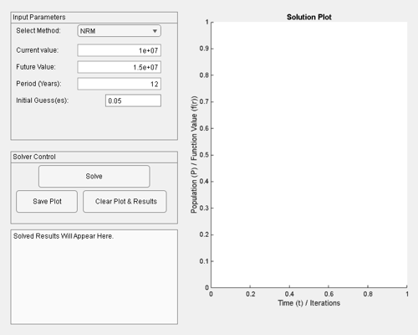

2.3With the inheritance from the numerical methods the following subclasses are created for solving computational problems

DIFFERENTIAL SOLVER BY INHERITING FROM NUMERICAL SOLVER
classdef DifferentialProblem < NumericalSolver
% Inherits from NumericalSolver and implements root-finding methods.
properties (Access = public)
% Encapsulation: Root-finding specific parameters.
tolerance = 1e-6;
max_iterations = 50;
method_used = 'None';
end
methods
function obj = DifferentialProblem(func, initial_guess)
% Calls Superclass constructor: RootFinder(@func, x0 or [x0, x1])
obj = obj@NumericalSolver(func, initial_guess);
end
function solve(obj, method)
% Polymorphism: Implements the abstract 'solve' method.
obj.method_used = lower(method);
x0 = obj.initial_data; % Initial guess(es)
switch obj.method_used
case 'nrm'
% NRM requires one initial guess
if length(x0) ~= 1
error('NRM requires one initial guess.');
end
obj.result_value = obj.newtonRaphson(x0);
case 'secant'
% Secant requires two initial guesses
if length(x0) ~= 2
error('Secant requires two initial guesses: [x0, x1].');
end
obj.result_value = obj.secantMethod(x0(1), x0(2));
otherwise
error('Unsupported root-finding method: %s.', method);
end
end
function displayResults(obj)
% Polymorphism: Implements the abstract 'displayResults'.
fprintf('\n Root-Finder (%s) Results:\n', upper(obj.method_used));
fprintf(' Initial Guess(es): [%s]\n', num2str(obj.initial_data));
if ~isnan(obj.result_value)
fprintf(' Calculated Root (r): **%.6f**\n', obj.result_value);
fprintf(' Function Value at Root: **%e**\n', obj.problem_func(obj.result_value));
fprintf(' Interest rate (r): **%.1f%%**\n', obj.result_value*100);
else
fprintf(' Failure: Solver did not converge in %d steps.\n', obj.max_iterations);
end
end
end
methods (Access = private)
% Encapsulated methods for the algorithms
function df = derivative(~, func)
% Numerical approximation of the derivative f'(x)
h = 1e-9;
df = @(x) (func(x + h) - func(x)) / h;
end
function root = newtonRaphson(obj, x0)
x = x0;
df = obj.derivative(obj.problem_func);
for i = 1:obj.max_iterations
x_new = x - obj.problem_func(x) / df(x);
if abs(x_new - x) < obj.tolerance
root = x_new; return;
end
x = x_new;
end
root = NaN;
end
function root = secantMethod(obj, x0, x1)
x_prev = x0;
x_curr = x1;
for i = 1:obj.max_iterations
fx_prev = obj.problem_func(x_prev);
fx_curr = obj.problem_func(x_curr);
if abs(fx_curr - fx_prev) < eps
root = NaN; return;
end
x_next = x_curr - fx_curr * (x_curr - x_prev) / (fx_curr - fx_prev);
if abs(x_next - x_curr) < obj.tolerance
root = x_next; return;
end
x_prev = x_curr;
x_curr = x_next;
end
root = NaN;
end
end
end

INHERITS FROM NUMERICAL SOLVER AND IMPLEMENTS ODE INTEGRATION METHOD
classdef IntergrationProblem < NumericalSolver
% Inherits from NumericalSolver and implements ODE integration methods.
properties (Access = public)
% Encapsulation: ODE-specific parameters (from the prompt).
r = 0.1; % growth rate
k = 1000; % carrying capacity
tspan = [0, 50];
num_steps = 500;
time_points;
solution_y;
method_used = 'None';
end
methods
% --- NEW CONSTRUCTOR (Handles r, k, and initial_pop) ---
function obj = IntergrationProblem(r_val, k_val, initial_pop)
% Constructor: Accepts r, k, and initial_pop from the App UI.
% Call Superclass constructor: Pass a dummy func and initial_pop (P0).
obj = obj@NumericalSolver(@(t, y) 0, initial_pop);
% Set the private properties using the values from the UI.
obj.r = r_val;
obj.k = k_val;
obj.time_points = linspace(obj.tspan(1), obj.tspan(2), obj.num_steps);
end
function solve(obj, method)
% Polymorphism: Implements the abstract 'solve' method.
obj.method_used = lower(method);
% The core ODE function for the Logistic model
f_ode = @(P) obj.r * P * (1 - P / obj.k);
switch obj.method_used
case 'euler'
[obj.time_points, obj.solution_y] = obj.eulerMethod(f_ode);
case 'rungekutta'
[obj.time_points, obj.solution_y] = obj.rungeKutta4(f_ode);
otherwise
error('Unsupported ODE solver method: %s.', method);
end
end
% --- NEW PUBLIC GETTER METHODS ---
function t = getTimePoints(obj)
% Public accessor for the private time_points
t = obj.time_points;
end
function y = getSolutionY(obj)
% Public accessor for the private solution_y
y = obj.solution_y;
end
function displayResults(obj)
% Polymorphism: Implements the abstract 'displayResults'.
fprintf('\n Intergral Solver (%s) Results:\n', upper(obj.method_used));
fprintf(' Initial Population (P0): %g\n', obj.initial_data);
fprintf(' Parameters: r=%.1f, K=%g, Timespan=[%g, %g]\n', obj.r, obj.k, obj.tspan(1), obj.tspan(2));
if ~isempty(obj.solution_y)
idx_mid = ceil(length(obj.solution_y) / 2);
fprintf(' Population (t=0): %.2f\n', obj.solution_y(1));
fprintf(' Population (t=%.2f): %.2f\n', obj.time_points(idx_mid), obj.solution_y(idx_mid));
fprintf(' Population (t=%.2f): **%.2f** (Final)\n', obj.time_points(end), obj.solution_y(end));
else
fprintf(' Failure: Solver was not executed.\n');
end
end
end
methods (Access = public)
% Encapsulated methods for the algorithms
function [t, y] = eulerMethod(obj, f_ode)
t = obj.time_points;
h = t(2) - t(1);
y = zeros(size(t));
y(1) = obj.initial_data;
for i = 1:length(t)-1
y(i+1) = y(i) + h * f_ode(y(i));
end
end
function [t, y] = rungeKutta4(obj, f_ode)
t = obj.time_points;
h = t(2) - t(1);
y = zeros(size(t));
y(1) = obj.initial_data;
for i = 1:length(t)-1
y_i = y(i);
% RungeKutta4 steps
k1 = f_ode(y_i);
k2 = f_ode(y_i + h/2 * k1);
k3 = f_ode(y_i + h/2 * k2);
k4 = f_ode(y_i + h * k3);
y(i+1) = y_i + (h/6) * (k1 + 2*k2 + 2*k3 + k4);
end
end
end
end

TEST GRAPHICAL USER INTERFACE FOR THE FOR THE HIGHLEVEL BACKEND CODES
function NumericalSolverApp
% NUMERICALSOLVERAPP Creates a graphical user interface for the numerical solvers.
% This script assumes that 'NumericalSolver.m', 'DifferentialProblem.m' and 'IntergrationProblem.m' are in the MATLAB path.
%1. Setup the Main Figure and Layout
f = uifigure('Name', 'NUMERICAL SOLVER APPLICATION', 'Position', [100 100 750 600]);
% Panel for Inputs
pInput = uipanel(f, 'Title', 'Input Parameters', 'Position', [20 350 300 230]);
% Panel for Controls
pControl = uipanel(f, 'Title', 'Solver Control', 'Position', [20 200 300 130]);
% Axes for Plotting
ax = uiaxes(f, 'Position', [340 50 400 530]);
title(ax, 'Solution Plot');
xlabel(ax, 'Time (t) / Iterations');
ylabel(ax, 'Population (P) / Function Value (f(r))');
% Text Area for Results
taResults = uitextarea(f, 'Position', [20 20 300 170], 'Editable', 'off', 'Value', {'Solved Results Will Appear Here.'});
% 2. Input Components (within pInput)
% Label for Method Selection
uilabel(pInput, 'Text', 'Select Method:', 'Position', [10 185 100 22]);
% Dropdown Menu for Method Selection
ddMethod = uidropdown(pInput, ...
'Items', {'NRM', 'Secant', 'Euler', 'RungeKutta'}, ...
'Value', 'NRM', ...
'Position', [120 185 150 22], ...
'ValueChangedFcn', @methodSelectionChanged);
% Labels and fields for parameters (dynamically change based on method)
lblParam1 = uilabel(pInput, 'Text', 'Current Value:', 'Position', [10 150 100 22]);
efParam1 = uieditfield(pInput, 'numeric', 'Value', 10000000, 'Position', [120 150 150 22]);
lblParam2 = uilabel(pInput, 'Text', 'Future Value:', 'Position', [10 120 100 22]);
efParam2 = uieditfield(pInput, 'numeric', 'Value', 15000000, 'Position', [120 120 150 22]);
lblParam3 =uilabel(pInput, 'Text', 'Period (Years):', 'Position', [10 90 100 22]);
efParam3 = uieditfield(pInput, 'numeric', 'Value', 12, 'Position', [120 90 150 22]);
lblGuess = uilabel(pInput, 'Text', 'Initial Guess(es) (r/P0):', 'Position', [10 60 150 22]);
efGuess = uieditfield(pInput, 'text', 'Value', '0.05', 'Position', [170 60 100 22]); % Initial guess for NRM/Secant
% Initial call to set up the fields for the default method (NRM)
methodSelectionChanged(ddMethod);
% 3. Control Components (within pControl)
% Solve Button
uibutton(pControl, 'Text', 'Solve', ...
'Position', [50 65 200 40], ...
'ButtonPushedFcn', @solveButtonPushed);
% Reset Button
uibutton(pControl, 'Text', 'Clear Plot & Results', ...
'Position', [50 20 200 40], ...
'ButtonPushedFcn', @resetButtonPushed);
% 4. Callback Functions
function methodSelectionChanged(src, ~)
method = src.Value;
switch method
case {'NRM', 'Secant'}
% Root Finding Parameters (f(r) = Current value*(1+r)^Period - future value)
lblParam1.Text = 'Current value:';
efParam1.Value = 10000000;
efParam1.Enable = 'on';
lblParam2.Text = 'Future Value:';
efParam2.Value = 15000000;
efParam2.Enable = 'on';
lblParam3.Text = 'Period (Years):';
efParam3.Value = 12;
efParam3.Enable = 'on';
lblGuess.Text = 'Initial Guess(es):';
if strcmp(method, 'NRM')
efGuess.Value = '0.05'; % Single guess
else
efGuess.Value = '0.05, 0.06'; % Two guesses
end
case {'Euler', 'RungeKutta4'}
% ODE Integration Parameters (dP/dt = r*P*(1-P/k))
lblParam1.Text = 'Growth Rate (r):';
efParam1.Value = 0.1;
efParam1.Enable = 'on';
lblParam2.Text = 'Capacity (K):';
efParam2.Value = 1000;
efParam2.Enable = 'on';
lblParam3.Text = 'Period (Years):';
efParam3.Value = 12;
efParam3.Enable = 'off';
lblGuess.Text = 'Initial Pop (P0):';
efGuess.Value = '10'; % Single initial population
end
end
function solveButtonPushed(~, ~)
try
method = ddMethod.Value;
if ismember(method, {'NRM', 'Secant'})
% --- Root-Finding Problem (DifferentialProblem) ---
Current_value = efParam1.Value; % The constant 10000000
Future_value = efParam2.Value; % The constant 15000000
Period_Years = efParam3.Value; % The constant 12
% The function: f(r) = A * (1 + r)^12 - B
rootFunc = @(r) Current_value * (1 + r).^Period_Years - Future_value;
% Parse initial guess(es)
guessStr = strsplit(efGuess.Value, {',', ' '});
initialGuesses = str2double(guessStr);
initialGuesses = initialGuesses(~isnan(initialGuesses)); % Remove invalid entries
if strcmp(method, 'NRM') && length(initialGuesses) ~= 1
error('NRM requires one initial guess.');
elseif strcmp(method, 'Secant') && length(initialGuesses) ~= 2
error('Secant requires two initial guesses (e.g., "0.05, 0.06").');
end
solver = DifferentialProblem(rootFunc, initialGuesses);
solver.solve(method);
% Capture display output
tempOutput = evalc('solver.displayResults()');
taResults.Value = strsplit(strtrim(tempOutput), '\n');
% Plotting (Root-Finding)
cla(ax);
r_vals = linspace(min(initialGuesses)/2, max(initialGuesses)*2, 100);
if isnan(r_vals(1)) % Fallback for bad initial guess
r_vals = linspace(-0.1, 0.2, 100);
end
f_vals = rootFunc(r_vals);
plot(ax, r_vals, f_vals, 'b-', 'LineWidth', 2);
grid(ax, 'on');
title(ax, ['Function Plot for ', upper(method)]);
xlabel(ax, 'Interest Rate (r)');
ylabel(ax, 'Function Value f(r)');
if ~isnan(solver.result_value)
hold(ax, 'on');
plot(ax, solver.result_value, 0, 'ro', 'MarkerSize', 10, 'LineWidth', 2);
legend(ax, 'f(r)', 'Calculated Root', 'Location', 'best');
hold(ax, 'off');
end
else
% --- ODE Integration Problem (IntergrationProblem) ---
r_val = efParam1.Value; % Growth rate 'r'
k_val = efParam2.Value; % Carrying capacity 'k'
% Initial Population
P0 = str2double(efGuess.Value);
if isnan(P0)
error('Initial population (P0) must be a single number.');
end
% Custom IntergrationProblem to use the current r and k values
customSolver = IntergrationProblem(r_val, k_val, P0);
customSolver.solve(method);
% Capture display output
tempOutput = evalc('customSolver.displayResults()');
taResults.Value = strsplit(strtrim(tempOutput), '\n');
% Plotting (ODE)
cla(ax);
plot(ax, customSolver.time_points, customSolver.solution_y, 'm-', 'LineWidth', 2);
grid(ax, 'on');
title(ax, ['Logistic Model Solution (', upper(method), ')']);
xlabel(ax, 'Time (t)');
ylabel(ax, 'Population P(t)');
legend(ax, 'P(t)', 'Location', 'best');
end
catch ME
% Display error message in the results area
taResults.Value = {['ERROR: ', ME.message]};
warning(ME.message);
end
end
function resetButtonPushed(~, ~)
cla(ax);
title(ax, 'Solution Plot');
xlabel(ax, 'Time (t) / Iterations');
ylabel(ax, 'Population (P) / Function Value (f(r))');
taResults.Value = {'Solver Results Will Appear Here.'};
end
end

Final Graphical User Interface
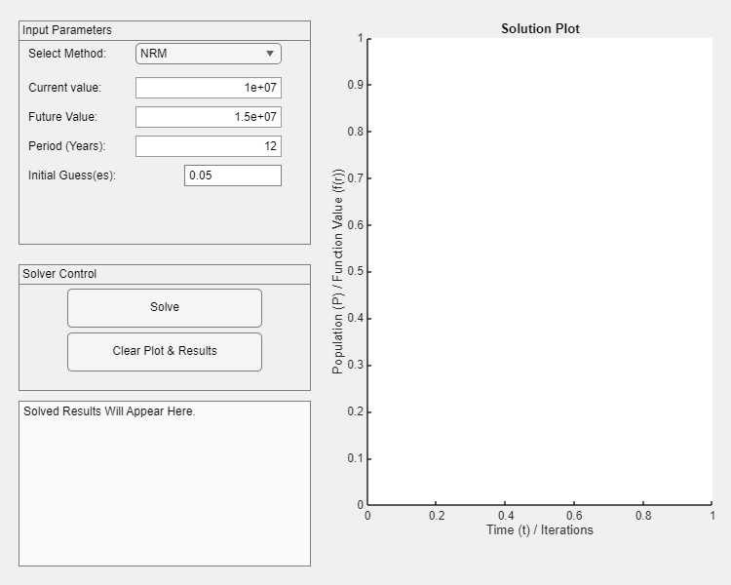
Results from the Newtons Raphson Method on input and click of the solve button
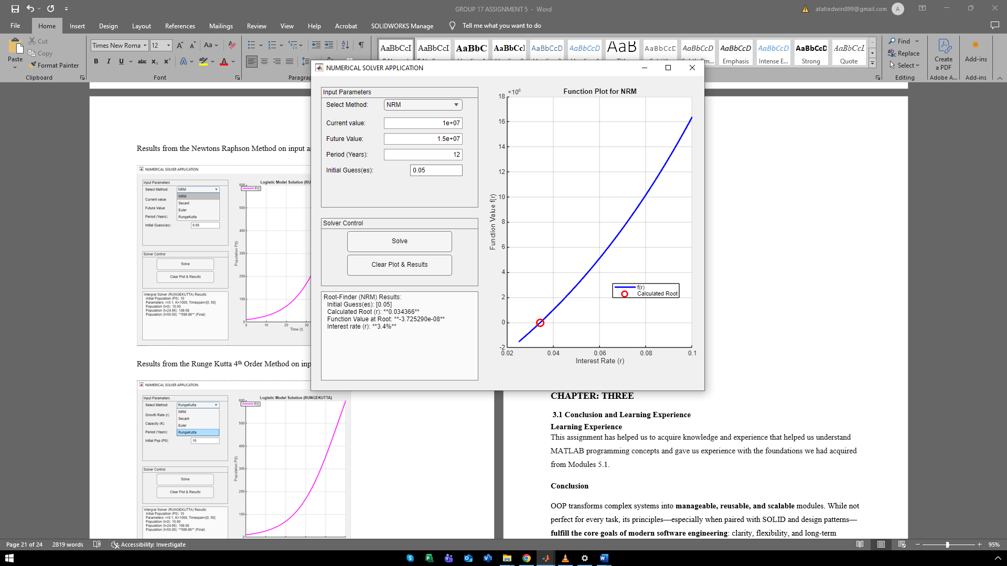
Results from the Runge Kutta 4th Order Method on input and click of the solve button
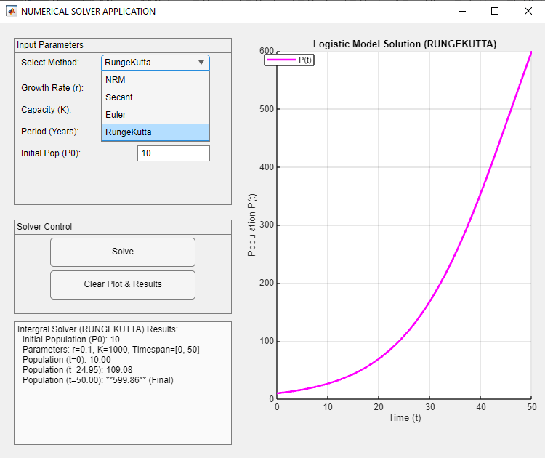

CHAPTER: THREE

3.1 Conclusion and Learning Experience

Learning Experience
This assignment has helped us to acquire knowledge and experience that helped us understand MATLAB programming concepts and gave us experience with the foundations we had acquired from Modules 5.1.

Conclusion
Graphical user interface concept and OOP transforms complex systems into manageable, reusable, and scalable modules. While not perfect for every task, its principles—especially when paired with SOLID and design patterns—fulfill the core goals of modern software engineering: clarity, flexibility, and long-term maintainability.

3.2 References and Resources
- MATLAB Documentation - Used for syntax and function guidance on legend (), fprintf ().
- Computer programming lecture notes.
- Gamma, E., et al. Design Patterns: Elements of Reusable OOP Software. Addison-Wesley, 1994.
- Fowler, M. UML Distilled. 3rd Ed.
- Oracle Java Documentation – docs.oracle.com
- Python Official Tutorial – MATLAB.org
- YouTube videos on Fibonacci sequence, recursive functions, dynamic programming, control structures and object-oriented programming.

